Visualization of Unemployment and Crime Rate across USA

##### Mingxuan Luo u1266548 u1266548@utah.edu

##### Yulan Wang u1264235 youlan9115@gmail.com

##### Qing Ye u6007114 [q.ye@utah.edu](mailto:q.ye@utah.edu)

## Basic Info.

Project repository:

<https://github.com/blackispower/Unemployment-in-USA>

## Overview and Motivation.

Unemployment is describing the state that a person above some specified age is not in paid [employment](https://en.wikipedia.org/wiki/Employment) or [self-employment](https://en.wikipedia.org/wiki/Self-employment) and are currently available for work during the [reference period](https://en.wikipedia.org/wiki/Reference_period). It is measured by the unemployment rate. Factors influencing unemployment rate may be caused by the [recession](https://en.wikipedia.org/wiki/Recession) of economy, new [technologies](https://en.wikipedia.org/wiki/Technology), policies of the government and so forth.

Crime rate is defined by the ratio of crimes in an area to the population of the area, which is a count of crimes complied to assess the effectiveness of a crime control policy, and the impact of the policy on the risk of crime victimization.

In our project, we decided to visualize the unemployment and crime rates across USA between 2007 to 2018. We would like to reveal the trend of unemployment of specific regions (country- level, state- level and county- level) over time. Since the data for crime rate, we only have country-level and state- level, we will visualize the trend of crime rate at country- level and state- level between 2007 to 2018. Meantime, we will analyze the relationship between Unemployment rate and Crime rate, and visualize their change trend over time. We also want to look at the unemployment rate and crime rate difference under the leadership with different presidents. We are interested in this topic because this is very relevant to our daily life. For individuals, these information could help them find an ideal place to settle down. For government, knowing the relationship between unemployment rate and crime rate could help goverment to make more effective crime control policy.

## Related Work.

Local Area Unemployment Statistics Map

<https://data.bls.gov/lausmap/showMap.jsp;jsessionid=79A96FEAED81F05DC79399CE15D59304._t3_07v>

## Questions.

### Reveal the trend of unemployment and crime rate of specific regions over time.

### Explore and compare the country- level, state- level and county- level unemployment rate. Same analysis for the country- level and state- level crime rate.

### Find the regions with extremely high or low  unemployment or crime rate.

### Visualize the trend of unemployment and crime both for specific regions. Check whether there might be an relationship between crime rate and unemployment rate.

## Data

### Data sources

#### Unemployment rate data:

Kaggle: <https://www.kaggle.com/jayrav13/unemployment-by-county-us>

Bureau of Labor Statistics <https://data.bls.gov/timeseries/LNS14000000>

#### Crime rate data:

Crime in the U.S. <https://ucr.fbi.gov/crime-in-the-u.s>

### Data Clean

The dataset provides us with the unemployment rate date in different counties across USA from 2007 to 2018.

#### Unemployment rate data:

First, we acquire the unemployment rate data for each county of each state from the website of UNITED STATES DEPARTMENT OF LABOR (<https://data.bls.gov/lausmap/showMap.jsp;jsessionid=79A96FEAED81F05DC79399CE15D59304._t3_07v>). Since the raw data is county-level, we need to preprocess the data to get aggregation of the data from county to state. Finally, we have the county level- unemployment rate data shown as Figure 1, and state level unemployment data shown as Figure 2.

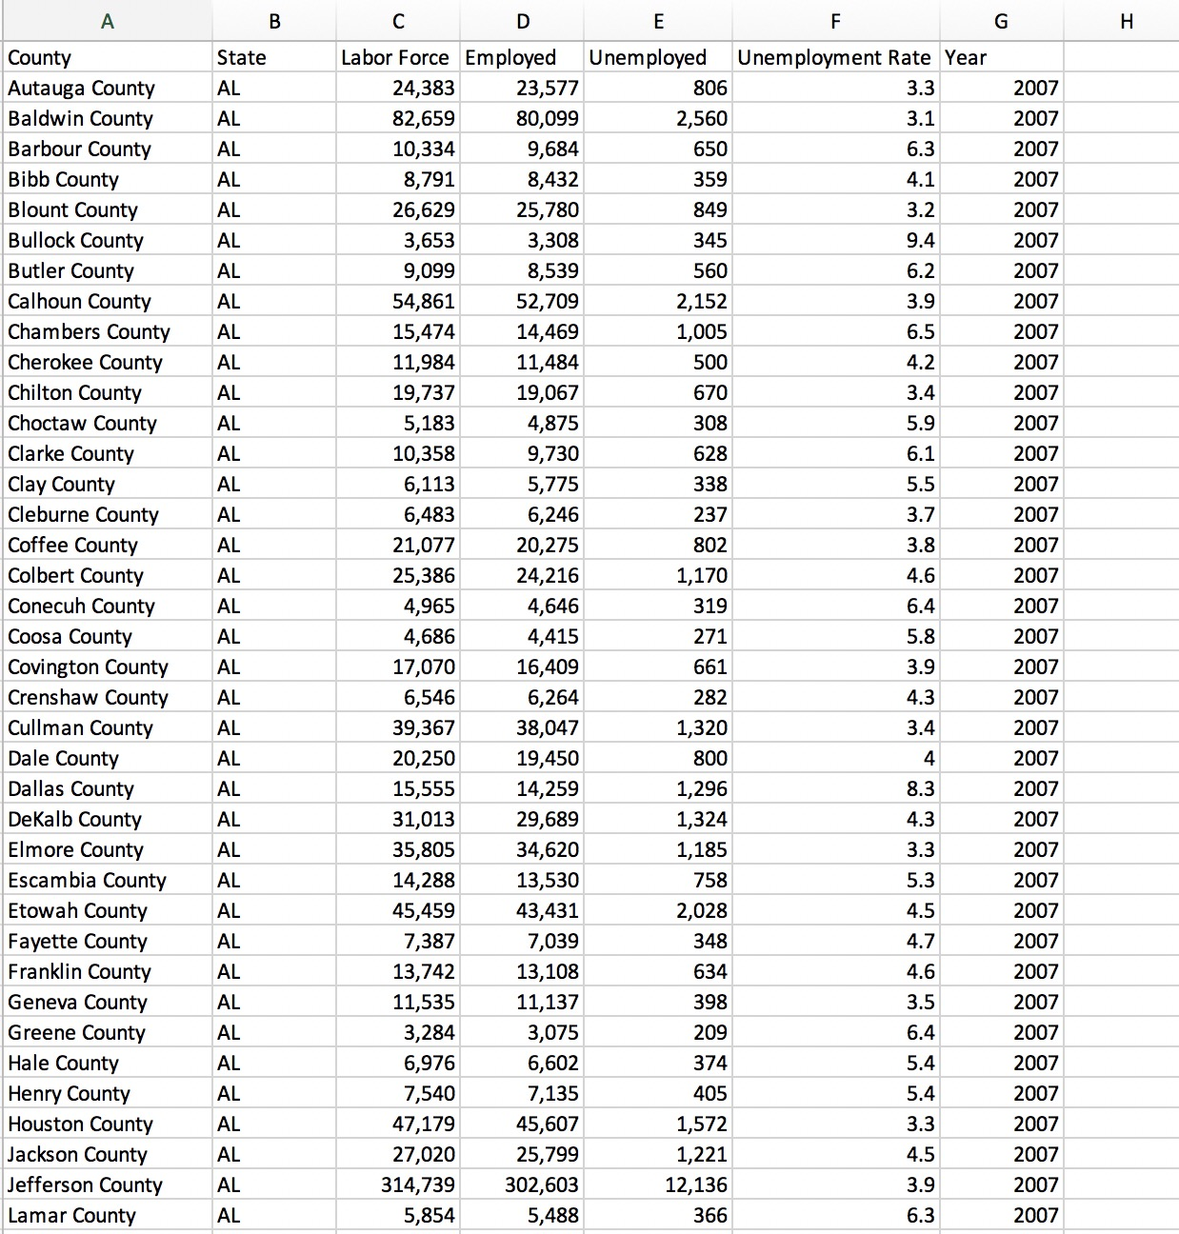

Figure 1. Unemployment data for each county of the US from 2007 to 2018.

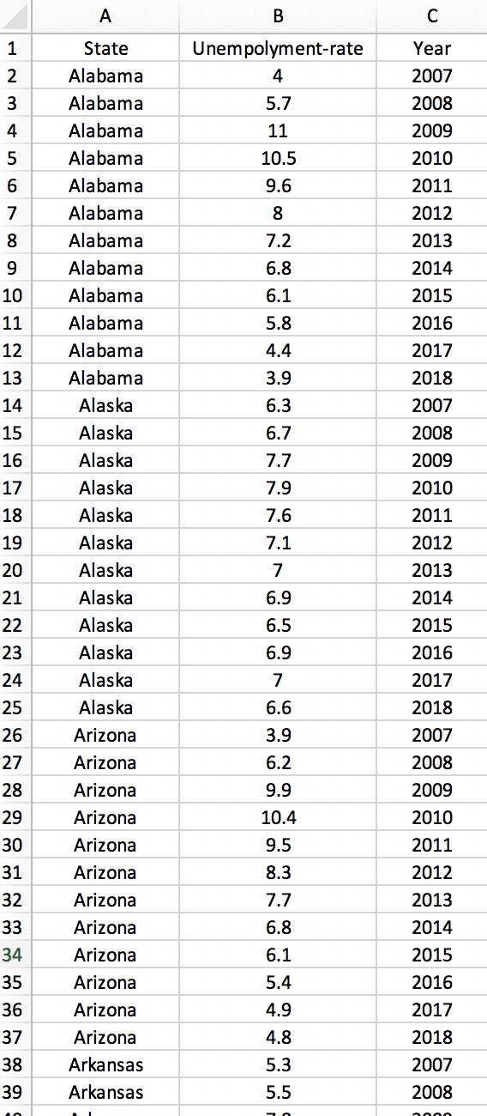

Figure 2. Unemployment data for each state of the US from 2007 to 2018.

#### Crime rate data:

For the crime rate data, we collected the data from the website <https://ucr.fbi.gov/crime-in-the-u.s>. After simple data clean process, the crime data is shown as Figure 3.

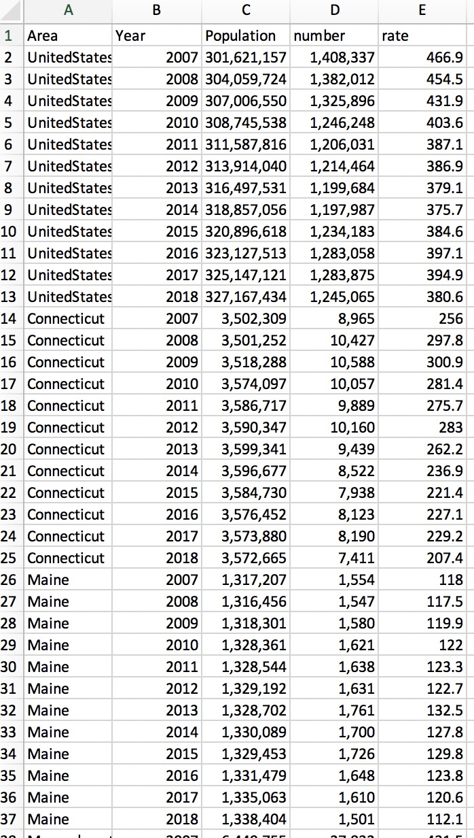

Figure 3. the crime data for each state in the US from 2007 to 2018.

## Exploratory Data Analysis:

We have used three kinds of visulizations for our data, including map chart, line chart and bar chart.

First, we used map chart to shown the unemployment or crime data. The map chart visualization makes has the ability to more easily understand the distribution of the organization’s presence across the city, state, or country, to compare the activity across several locations at a glance, and contextualizing data in the real world. Second, to visualize the data change trend, we used line chart. Line chart can show data variables and trends very clearly. It’s also useful to compare the trend of two kinds of data and show their relationship. Third, bar chart was used to visualize the data for each state or county. Compare to map chart, bar chart was marginated by length. The benefits of bar chart includes displaying relative differences of multiple categories, summarize the extremely value of the data.

We also used several interaction in our project that including hover, zoom, sorting, linking among different graph.

## Design Evolution

### The original design:

#### Overview

The overview of the visualization consists of three parts: map chart, line chart and bar chart, and can toggle between the unemployment rate, the crime rate and the combined view.

Map chart is coded by color, suggesting the rate of unemployment/crime rate in each state. And on the combined view, the color indicates the unemployment rate while the crime rate is represented by the size of a circle. A year slider on the bottom can switch between different years. A tool tip should appear on hover. If a state is clicked, the map would zoom in and show a more detailed unemployment rate information in different counties. (Figure 4 -6).

Line chart for the first two view shows the change over the years and it would highlight the corresponding line for a state when hovering on a specific one. It changes into a scatter plot with X-axis and Y-axis showing the stastitics. When clicking on a state, because we only have data for unemployment rate for each county, the line chart only show changes for the unemployment rate for each county. A description box shows the crime rate and overall unemployment rate in the state. (Figure 4 -6).

Bar chart shows the comparison between states/counties for a specific year. Hovering on map or a bar would highlight each other. The whole chart could sort by alphabetic order or the statistics (Figure 4 -6).

Additional functions: we are thinking of let users to choose over 2 states to compare the unemployment rate of those states (Figure 7).

#### Must-Have Features.

Three views for the map chart and the corresponding functions in line and bar charts

#### Optional Features.

Zooming function for each counties’ data.

We still follow our proposal. However, we will try to add more feature and interactive to our project.

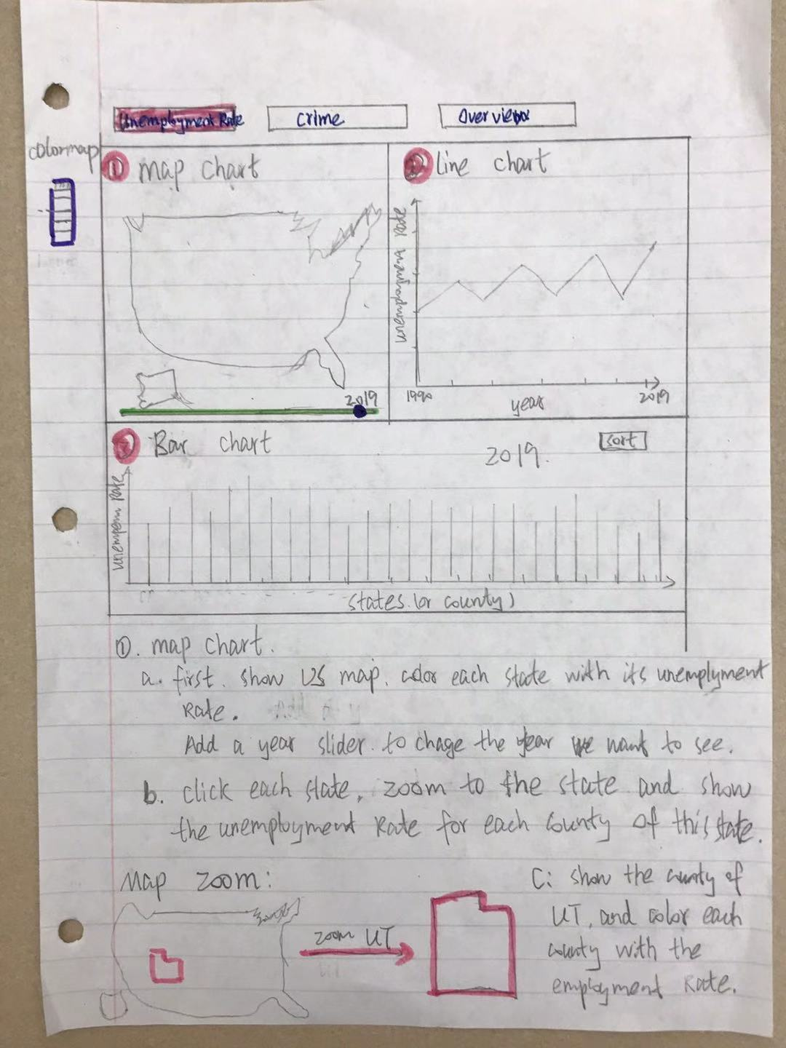

Figure 4

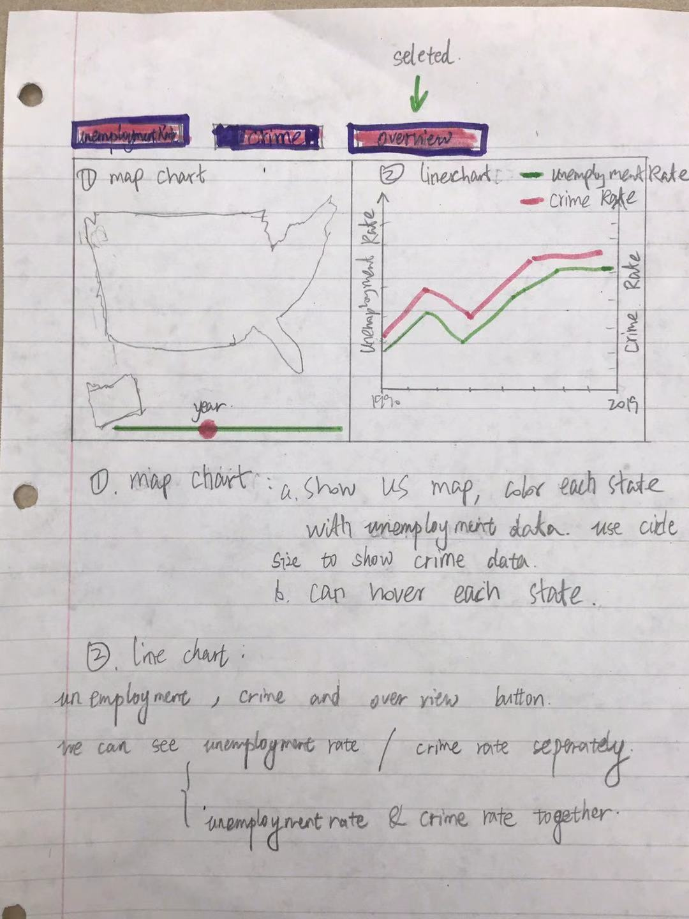

Figure 5

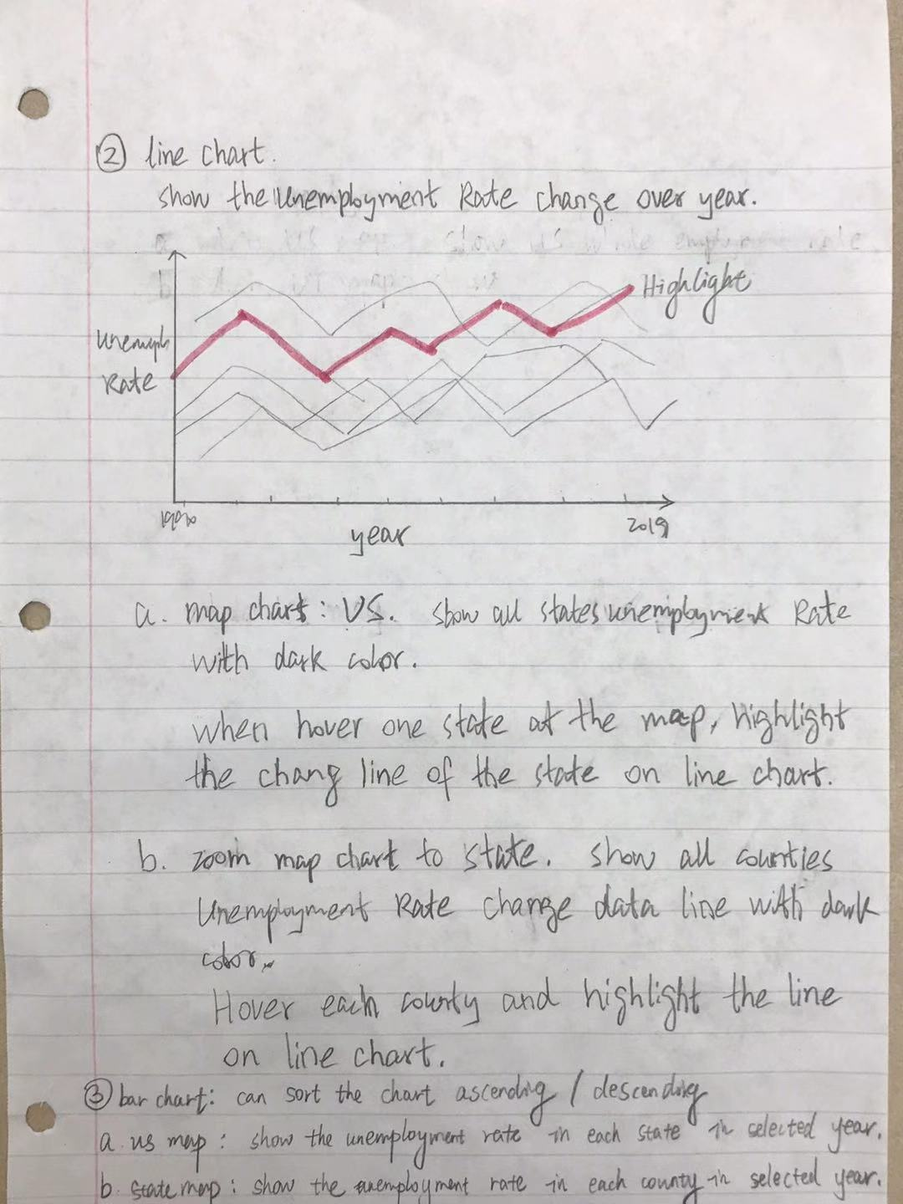

Figure 6.

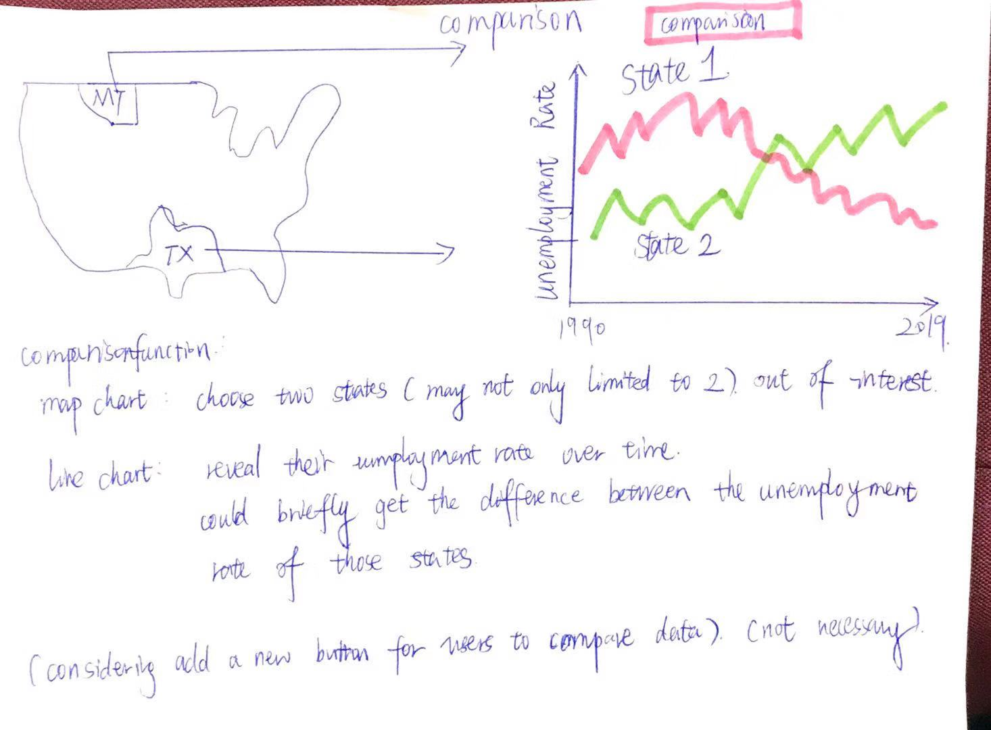

Figure 7. Compare the unemployment rate and crime rate for specific area.

### Implementation.

#### The map chart

In the map chart, shown as figure 8, we colored the unemployment rate for each state.

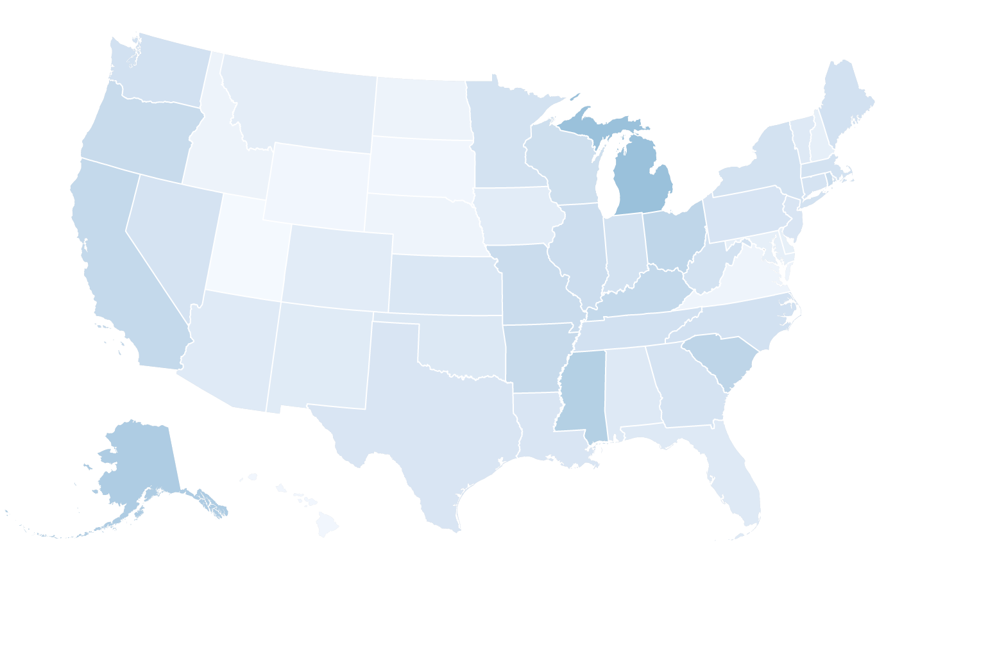

Figure 8. the map chart of Unemployment rate of the US.

We can zoom each state (shown as Figure 9) and shown its county data (we are still woring on it).

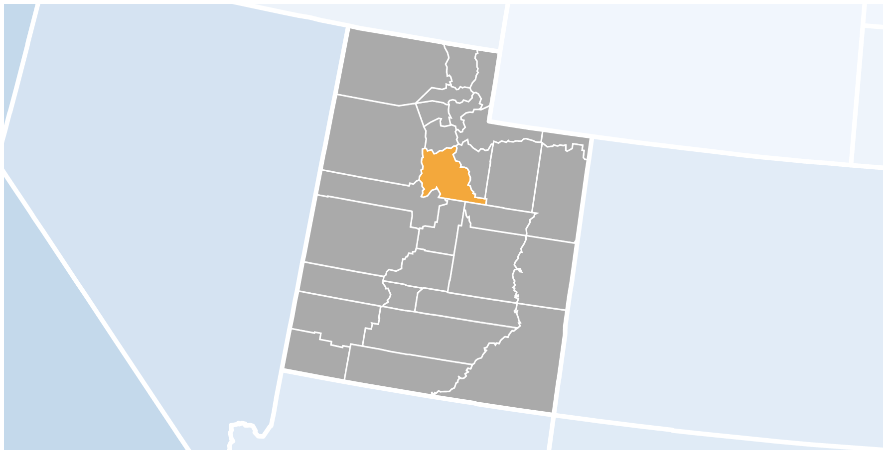

Figure 9. Zoom to Utah (we will add the county data later). For each county, we can hover it.

#### The line chart

The change trend of unemployment or crime rate for specific area.

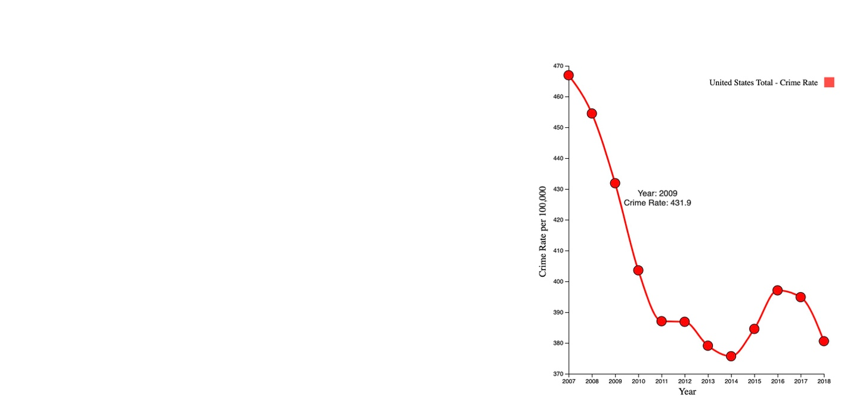

Figure 9. the trend of crime rate at the US from 2007 to 2018.

#### The bar chart

For the bar chart, in unemployment rate page or crime page, when we select specific year with year slider, the bar chart shows the unemployment rate or crime rate for all states. The bars can be sorted by “Alphabetical”, “Frequency, ascending” or “Frequency, descending”. Each bar can be hovered as Figure 10.

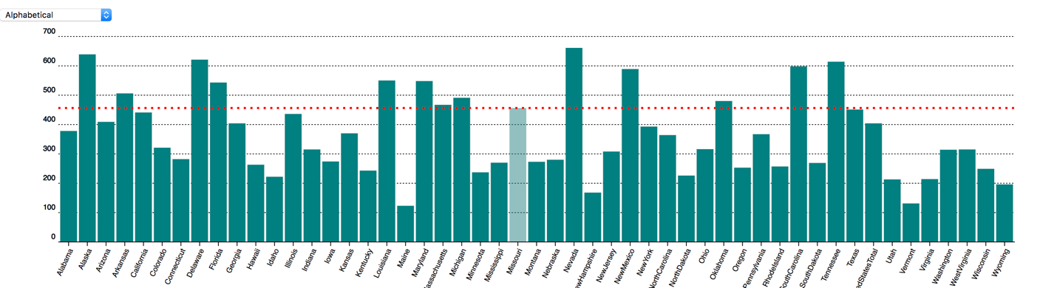

Figure 10. the crime rate of each state in the US at 2010.

#### Overview of map chart and bar chart

The overview of map chart and bar chart shows the data in two difference visualizations. When hover map chart or bar chart, another chart could be hovered in the meantime.

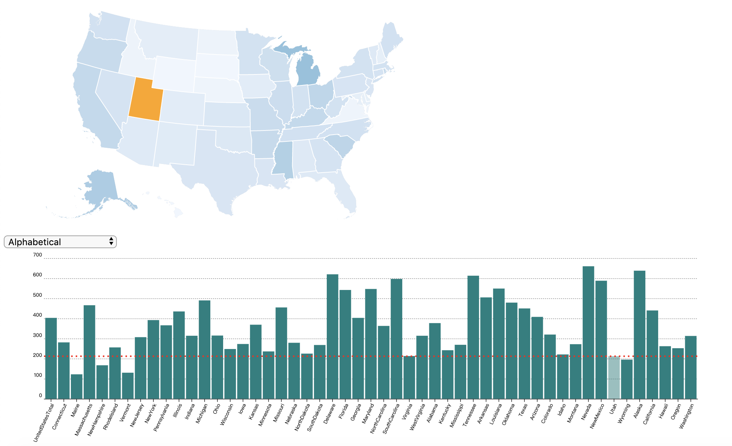

Figure 11. the overview of map chart and bar chart.

## Evaluation.

#### Learning:

1. Based on the map chart, we could know the unemployment or crime rate difference around the distributions of the US.
2. Based on the bar chart, the unemployment or crime rate order of specific state could be identified. With soring, the extremely value (the highest and the lowest) of data are easy to distinguished.
3. Based on the line chart, the change trend of data is easy to understand.

#### Improvement:

More interactives, storytelling will be implemented.